# Module 3 Practice Quiz 4

**6/6** points earned (100%)

Excellent!

Retake

[Course Home](https://www.coursera.org/learn/corporate-finance/home/welcome)

Correct

1 / 1 points

1. You are the CFO of a drug company, and you must decide whether to invest 50M dollars in R&D for a new drug. If you conduct the R&D, you believe that there is a 10% chance that the research will produce a useful drug. If the research is successful, investment in the drug will require an outlay of 1.5 billion dollars. The drug will likely generate annual profits of 300 million for 10 years until the patent expires. After that, it will generate a cash flow in perpetuity equal to 25 million. The discount rate is 7%.

If the research is successful, the net present value of the drug cash flows is _______.

1. 657 million
2. **789 million**

**Correct Response**

The cash flows are:

|  |  |  |  |  |  |  |  |  |  |  |  |  |
| --- | --- | --- | --- | --- | --- | --- | --- | --- | --- | --- | --- | --- |
| 1 | 2 | 3 | 4 | 5 | 6 | 7 | 8 | 9 | 10 | 11 | 12 |  |
| 300 | 300 | 300 | 300 | 300 | 300 | 300 | 300 | 300 | 300 | 25 | 25 | ... |

So the present value is:

PV = 300/(1 + 7%) + 300/(1 + 7%)^2 + ... + 300/(1 + 7%)^10 + (25/7%)/(1 + 7%)^10 = 2,289

Since the required investment is 1,500, the NPV is 789 million.

1. 514 million
2. 720 million

Correct

1 / 1 points

2. You are the CFO of a drug company, and you must decide whether to invest 50M dollars in R&D for a new drug. If you conduct the R&D, you believe that there is a 10% chance that the research will produce a useful drug. If the research is successful, investment in the drug will require an outlay of 1.5 billion dollars. The drug will likely generate annual profits of 300 million for 10 years until the patent expires. After that, it will generate a cash flow in perpetuity equal to 25 million. The discount rate is 7%.

If you invest in R&D, you estimate that it will take 3 years to know whether the drug is successful or not. What is the NPV of the R&D investment?

1. **14.3 million**

**Correct Response**

You can build a tree as we did in the lecture

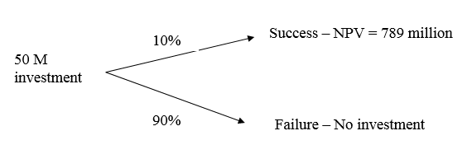

So the NPV is:

-50 + 10% * 789/(1 + 7%)^3 = 14.3

1. 16.21 million
2. 15.74 million
3. 9.57 million

Correct

1 / 1 points

3. Consider the gold mine problem we solved in Module 3 but assume that the parameters change such that the profits you make in each state of the world if the mine is open are now.

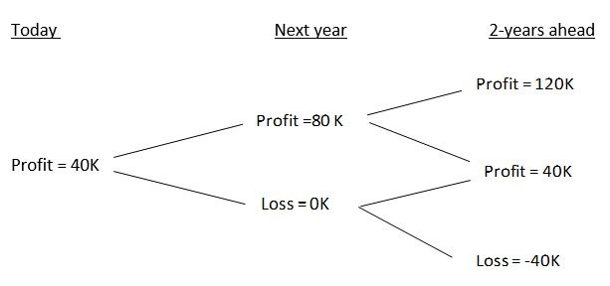

Notice that these values correspond to a case in which the volatility in the price of gold is lower than in the lecture notes. The discount rate is still 5%, and the cost of opening the mine is still 70 as in the lecture notes.

The NPV of opening the mine today and keeping the mine open is now equal to:

1. 49,431
2. 45,456
3. **44,367**

**Correct Response**

The NPV is:

NPV = -70 + 40 + (50%*80 + 50%*0)/ (1+ 5%) + (25%* 120 + 50%*40 – 25%*40)/ (1+5%)^2 = 44,367

Notice the NPV is still the same! The reduction in uncertainty does not change the NPV of opening the mine today. This is because the reduction in uncertainty does not change the expected cash flows in this case.

1. 47,235

Correct

1 / 1 points

4. Consider the gold mine problem we solved in Module 3, but assume that the parameters change such that the profits you make in each state of the world if the mine is open are now:

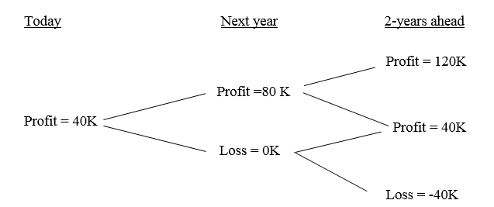

Notice that these values correspond to a case in which the volatility in the price of gold is lower than in the lecture notes. The discount rate is still 5%, and the cost of opening the mine is still 70 as in the lecture notes.

The NPV of waiting to open the mine tomorrow is now:

1. 47,528
2. **41,043**

**Correct Response**

The profit tree in this case is now:

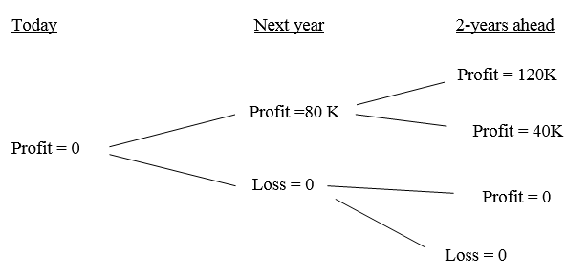

So the NPV is:

NPV = 50%*(-70 + 80 )/ (1+ 5%) + (25%* 120 + 25%*40)/ (1+5%)^2 =

= 41,043

As we discussed in class, the reduction in uncertainty significantly reduces the value of the option to wait.

1. 50,340
2. 42,220

Correct

1 / 1 points

5. Consider the gold mine problem we solved in Module 3 but assume that the parameters change such that the profits you make in each state of the world if the mine is open are now:



Notice that these values correspond to a case in which the volatility in the price of gold is lower than in the lecture notes. The discount rate is still 5%, and the cost of opening the mine is still 70 as in the lecture notes.

Is the following statement true or false?

With the reduction in uncertainty, the optimal decision is now to open the mine today.

1. **True**

**Correct Response**

The NPV of opening today is 44,367, and the NPV of waiting is 41,043, so it is better to open today.

1. False

Correct

1 / 1 points

6. Consider the gold mine problem we solved in Module 3 but assume that the parameters change such that the profits you make in each state of the world if the mine is open are now:



Notice that these values correspond to a case in which the volatility in the price of gold is lower than in the lecture notes. The discount rate is still 5%, and the cost of opening the mine is still 70 as in the lecture notes.

Is the following statement true or false?

If a competitor has the opportunity to invest in a similar project, then the option to wait for more information before investing may not be very valuable.

1. **True**

**Correct Response**

As we discussed in the lecture notes, an investment by a competitor may reduce profits if a company decides to wait. It may be better to invest today and preempt entry by the competitor.

1. False